**Literature Review**

This chapter is about a literature review on the topic Driver Fault Detection and Prediction System. This chapter describes about the existing systems which are relevant to this project and the technologies that we can use for this system.

In modern society, there occurs many road accident because of the careless driving of the drivers. There are many rules that have to be adhere by the drivers when they are driving. They are known as the driving laws. Some of the driving laws are as following.[1]

* Seat Belt Laws
* Drinking and Driving
* Must have clear documents
* Speed Limits

The speed limits for Sri Lanka are as follows:

Open roads: 72 km/h

In Town: 56 km/h

Motorway/Highway 120 km/h

* Minimum Driving Age
* Child Safety Rules
* Insurance
* Rules of the Road

Standard international driving laws apply with one or two exceptions.

Many drivers completely ignore road rules so drive with caution

Fully tinted windows are illegal

Sri Lanka drives on the left

* Towing Regulations
* Speed Cameras
* Using Mobile Phones when driving
* Parking

So the traffic police is tend to charge fine from the drivers who are breaching the rules when they driving or using the vehicles.[2] The drivers who are breaching the rules have to pay fine according to the offence that they have done or they might sent in front of the courts. As per the manual system that use by Sri Lankan traffic police at present if someone get caught to the traffic police by breaching the road rules, the police will take their driving licence card and issuing a and issuing a temporary licence until the driver pay the fine. So the driver has to pay the fine to the post office and get the receipt issuing by the post office. After that he have to forward that receipt and get the licence card from the respective police station which the driver got caught.

The current system is a method which is very tough to the drivers. Because they have to take their licence from the respective police station. If the driver is from a very far area, he have to again come to the respective police station to collect his licence.[3] So this is very difficult to the people who having very busy life in this present society. But this is an act of a parliament which have been granted to reduce the faults done by the drivers. When drivers have to go on such process to get their licence back, the government thinking that the offences on road will be reduced in to some amount. But when looking at the offences done by the drivers on the road we can see that it haven’t been reduced. So we have to look at a new method to reduce the road accidents. If we have a method to find the drivers who are doing offences frequently the police can take an action against then by cancelling their driving licence or by giving some other punishment to wrongful drivers.

The proposed system is specially designed system to the traffic police to get the data of the wrongful drivers and analyze their character. Even the insurance companies which used to insure the vehicles can use this system to analyse about their customers who are claiming frequently[4] .From this the police can take a report of a driver automatically at the end of a time period and the system will automatically judge the quality of the driver. Here when a driver get caught to a policemen by doing an offence the policemen can update the system online by entering the licence card number of the driver to the system and entering the offence done by the driver. So the at the end of the time period the system will decide to cancel the driving licence of the wrongful drivers by analyzing the weight of their offences and the number of the offences on the road.

If driver did not pay the fines during a certain period of time system will give a notification to the police station which the driver is belongs. So the police can bring him in front of the courts. If the driver get caught to the police again during a certain period of time the system will notify it to the police. These data can be taken to the analyzing of the character of the drivers and make the validation of their driving licence.

In Sri Lanka the number of the road accidents are increasing day by day. This is because of the careless driving of the drivers and breaching the road rules. When looking at the statics of previous years we can get to know how they have increased with the time.[5]



When we are looking at these statics we can understand that how the number of accidents increased with the time. As an example when we look at the motor cycles and the Three- Wheelers there is considerable increase.

So the traffic police is doing a great job to decrease these accidents and fine the wrongful drivers.

In following images it is shown an image of a valid driving licence in Sri Lanka and the permit issued by a police officer in a lieu of the driving licence.

 

A valid Driving Licence Card The permit issued by a police officer

in a lieu of the driving licence

Following procedure is normally using by a driver to get the driving licence back after getting caught to the traffic police.[3]

**Step 1:** The Driver breaks a traffic rule(s)

**Step 2:** Police confiscates drivers [driving license](http://www.gic.gov.lk/gic/index.php?option=com_info&id=390&task=info&back=0&pid=475&lang=en).

**Step 3:** Police issue a spot fine statement

**Step 4:** Driver goes to office and receives a fine payment form from the traffic division.

**Step 5:** Driver goes to post office and pays fine for which he/she receives a receipt.

**Step 6:** Driver goes to police station, shows receipt and police return [driving license](http://www.gic.gov.lk/gic/index.php?option=com_info&id=390&task=info&back=0&pid=475&lang=en).

**Note 1:** If driver didn’t pay the fine he/she will be submitted to court

**Note 2:**If driver hasn’t [driving license](http://www.gic.gov.lk/gic/index.php?option=com_info&id=390&task=info&back=0&pid=475&lang=en). Police issue another permit (police 405- Code of criminal Procedure Section 109(6) Act, No. 15 of 1979)

This manual system is only available system for the fine paying system at present for Sri Lanka. Making all the things to online is a difficult task in Sri Lanka. Because there are many driver who do not having idea about online payments and drivers who do not use credit cards. Online traffic fine payment is available in some foreign countries but it is not available still in Sri Lanka.[6]

A driver improvement points system where motorists would have their driving licences cancelled on points accumulated for traffic offences, will be in place before year end. The proposal initially made more than two years back. Points regarding other offences have also been determined, but will be implemented only in the second phase. The Motor Traffic Department will collect data from police stations and courts on a monthly basis to update their records. The records will be available to police stations through a card reading system or a mobile application, where police can check on the points accumulated to date. But this system is still not implemented to the police stations.

In this system it will give points to the offences done by the drivers when they using vehicles. The ponts will be added in following method.[7]

|  |  |
| --- | --- |
| Offence | Driver Improvement Points |
| Reckless Driving and Accidents |  |
| Failing to such action on road to prevent an accident | 06 Points |
| Driving a motor vehicle on a road recklessly or in a dangerous manner at a dangerous speed. | 08 Points |
| Driving a motor vehicle negligently or without reasonable consideration | 08 Points |
| Failing to stop after accident on road and furnish relevant information | 10 Points |
| Failing to report an accident forthwith to the nearest police station | 04 Points |
|  | |
| Speeding |  |
| Exceeding the prescribed speed limit on a road | 06 Points |
|  | |
| Road Rules |  |
| Failing to, | |
| 1. Keep left or nearside of the road |  |
| 1. Allow a motor vehicle being overtaken by the traffic |  |
| 1. Overtake other traffic without a clear view of the road ahead. |  |
| 1. Overtake other traffic without keeping to the right. |  |
| 1. Drive alongside of or overtake, other traffic proceeding in the same direction, in such manner as to obstruct any traffic proceeding in the opposite direction. |  |
| 1. Cross or commence to cross road or turn in a road in such manner without, obstructing any traffic on the road. |  |
| 1. Proceed from a place which is not a road in to a road or from a road to a place which is not a road in such a manner without obstructing the traffic on the road |  |
| 1. Proceed from one road without obstructing the traffic on the other road. |  |
| 1. Turn in to or cross a main road without obstructing the traffic on the road. | 04 Points |
| 1. Give way to the traffic coming on right side of the junction |  |
| 1. Give way to the vehicles approaching a narrow road |  |
| 1. Give way to the vehicles approaching each other on a narrow road. |  |
| 1. Turn right without violating the correct maneuvering procedure |  |
| 1. Stop and proceed from any place to a road before entering such roads where stop lines are painted. |  |
| Reversing or permitting the vehicle to travel backwards on a road for a long distance | 04 Points |
| Failing to comply with prohibitory, restrictive, mandatory or priority signs | 06 Points |
|  | |
| Signaling |  |
| Failing to comply with the oral directions or hand signals given by a police officer or a traffic warden. | 06 Points |
|  | |
| Pollution |  |
| Driving a motor vehicle which has above the prescribed standards. | 04 Points |
| Using or permitting to use amplifying equipment in a volume of sound above the prescribed standards. | 04 Points |
| Using a vehicle the noise of the engine and the horn of which exceed the prescribed standards. | 04 Points |
|  | |
| Construction and Use of Vehicle |  |
| Driving a vehicle the condition of which causes or is likely to course danger or harm any person, property or vehicle on or adjoining the road. | 10 Points |
|  | |
| Safety |  |
| Driver failing to wear the seat belt or failing to ensure the front passenger wears seat belt. | 03 Points |
| Failing to stop before the give way line of a zebra i crossing while pedestrian is at a pedestrian crossing. | 06 Points |
| Ride of a motor cycle carrying more than one person or falling to wear a safety helmet. | 04 Points |
| Using hand held communication equipment while driving | 04 Points |

The proposed system is somewhat different than this system. It is a system that can predict about the drivers intelligently. It will automatically detect the faults of the drivers and predict them. This system can automatically give points to the wrongful drivers and after a period of time the system can automatically analyse quality of the drivers who are doing offences frequently and nominate those drivers to the licence card cancellation list. We can use machine learning techniques to do these tasks.[8], [9]. We can train data sets according to some patterns and after that we can easily find the drivers who should be nominated to reject list and we can predict about them by seen their past records.

Machine learning will solve the problems that are in the real world by building model that that is good and useful approximation to the data. The study of Machine learning has grown from the efforts of exploring whether computers could learn to mimic the human brain, and a field of statistics to a broad discipline that has produced fundamental statistical computational theories of learning processes. In machine learning it advanced the algorithm in with in the general areas of supervised learning and unsupervised learning. At present the adaptive programing is consists in machine learning where those programs are capable of recognizing patterns, learning from experience, getting new information from the collected data and optimizing the accuracy and efficiency of the processing of output result. [10]

Today the machine learning algorithms have been developed to a high standard level. They are not as the machine learning algorithms which were there previously. Because of these developments the the machine learning has the ability to apply complex mathematical calculations very faster. [11]

**Machine Learning Model**

The learning process in the machine learning model is divided in to two parts as training and testing[12][13].

* Training
* Testing

In data training process in machine learning, samples of training data are taken as input in which features are learned by learning algorithm or learner and build the learning model. In the testing process, learning model uses the execution engine to make the prediction for the test or production data. Output of the learning model is tagged data it gives the final prediction or classified data.

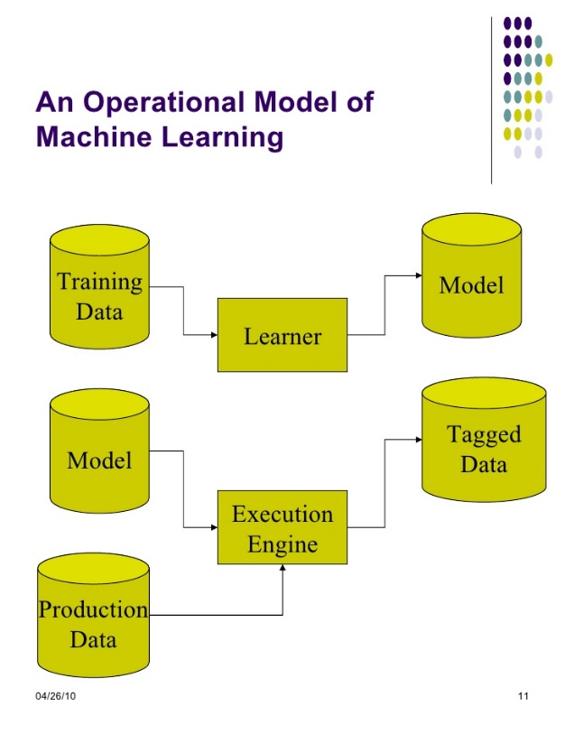

Operational model of machine learning

In machine learning there are machine learning techniques[14]. They can be categorized in to several categories as.

* Supervised Learning.
* Unsupervised learning.
* Semi Supervised Learning.
* Reinforcement Learning.

Supervised Learning

Supervised learning is a technique that which is using labeled examples. That means when entering data we know the desired output. Supervised learning provides set of data which consists of both features and labels. The task or the objective of the supervised learning is to construct an estimator which is able to predict the label of an object given the set of features. Along with the corresponding correct outputs, the supervised learning algorithm receives a set of features as inputs. To find the errors the learning algorithm compares the actual output with the correct output. By this process the algorithm can learn about the data. The algorithm modifies the model accordingly after learning the pattern. This supervised learning method is not needed as long as the inputs are available. But if some input values are missing it will not able to infer anything about the outputs. Supervised learning is commonly used in applications where historical data predicts likely future events. Tasks of supervised learning are divided in to two parts. They are,

1. Classification
2. Regression

In classification part the label is discrete and in regression part the label is continuous.

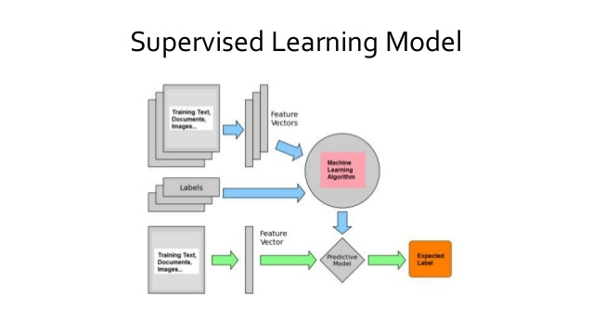

Supervised Learning Model

Unsupervised Learning

In unsupervised learning it is used the data that do not have historical labels. In unsupervised learning the goal is to explore and finding similarities between the objects. That is the method of finding labels of the data from itself. This works well on transactional data as identify segments of customers with similar attributes who can then be treated similarly in marketing campaigns.

There are some other unsupervised problems. They are,

* Given detailed observations of distant galaxies –

This determines the features or combinations of the features that are very much important in distinguishing between galaxies.

* Given a mixture of two sound sources for example

A song playing with the music and voice is a good example for this. A human voice and an instrumental voice is there. The separation of these two sounds is called as blind source separation.

* Given a video

Isolating a moving object in a video and matching and categorizing with other moving objects which can be seen.

Clustering is a typical unsupervised learning task and it is divided into groups. Not as in classification, those groups are not known before. Popular unsupervised learning techniques are include,

- Self-organizing maps

- Nearest-neighbor mapping

- k-means clustering

- Singular value decomposition

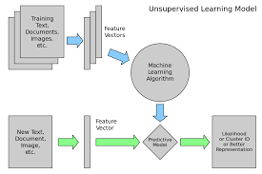

Unsupervised Learning Model

Semi-supervised Learning

Semi-supervised learning is used for the same applications as supervised learning but it uses both labeled and unlabeled data for training. In semi-supervised learning there is a desired prediction problem but the model must learn the structures to organize the data as well as make predictions.

This type can be used with the method like classification, regression and prediction.

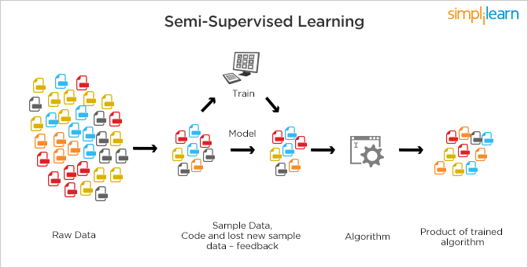

Semi-supervised Learning

Reinforcement Learning

The reinforcement learning method can be used in the areas like robotics, gaming and navigation. Reinforcement learning is the learning technique which interacts with a dynamic environment in and it perform a certain goal without a teacher explicitly telling it whether it has come close to its goal. In reinforcement learning method it identifying the trial and the errors. It will benefited to get more rewards when working with it.

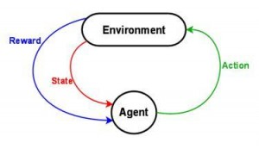

Reinforcement Learning

MAHINE LEARNING ALGORITHMS

To build machine learning models and to implement iterative machine learning process there are set of machine learning algorithms that are developed by the various researchers. Those algorithms can be classified according to the learning style of them. Those algorithms are as follows.

1. Regression algorithms

Regression is the ability an algorithm of predicting the value of a continuously varying variable such as a price, a temperature if given some input variables like features and regressor . Most commonly used regression algorithms are,

* Ordinary Least Squares Regression (OLSR)
* Linear Regression
* Logistic Regression
* Stepwise Regression
* Multivariate Adaptive Regression Splines (MARS)
* Locally Estimated Scatterplot Smoothing (LOESS)

1. Instance-based Algorithms

This method also called a lazy learner method. In this algorithm it takes less time in training and more time in prediction. This builds a data base of training data and typically compare with the test data and looking about best match and make a prediction[15]. Common types of Instance-based algorithms are,

* k-Nearest Neighbour (kNN)
* Learning Vector Quantization (LVQ)
* Self-Organizing Map (SOM)
* Locally Weighted Learning (LWL)

1. Decision Tree Algorithms

In the decision tree algorithm it uses a tree as the predictive model. The tree can match observations about an item to conclusions about its target value. In tree models the target variable can get finite set of values. That is known as classification trees. In decision tree structures branches represent conjunctions and the leaves represent class labels. These are fast and accurate algorithms.[16] Most common decision tree algorithms are,

* Classification and Regression Tree (CART)
* Iterative Dichotomiser 3 (ID3)
* C4.5 and C5.0 (different versions of a powerful approach)
* Chi-squared Automatic Interaction Detection(CHAID)
* Decision Stump
* M5
* Conditional Decision Trees

1. Bayesian Algorithms

These Bayesian algorithms are based on the probability theory. Machine learning is a hybrid product of statistics and algorithmic computer science. Statics is about managing and quantifying of uncertainty. Most commonly used Bayesian algorithms are,

* Naive Bayes
* Gaussian Naive Bayes
* Multinomial Naive Bayes
* Averaged One-Dependence Estimators (AODE)
* Bayesian Belief Network (BBN)
* Bayesian Network (BN)

1. Clustering Algorithms

Clustering is the method of classifying objects in to groups. Clustering algorithms are classifying the data in to subsets or the clusters. Clustering methods are classified as hierarchical clustering and partitional clustering. K-means is partional clustering algorithms which uses centroid-based approach[17].

* k-Means
* k-Medians
* Expectation Maximisation (EM)
* Hierarchical Clustering

1. Association Rule Learning Algorithms

This extracts the best rules. Explains the observed relationships between variables of data. The common algorithm types are,

* Apriori algorithm
* Eclat algorithm

1. Artificial Neural Network Algorithms

Artificial neural networks are used in the supervised learning and those neural networks are constructed by considering the structure of biological neural networks[18], [19]. These are consisted with artificial neurons and they are learned by tuning the connection weights to perform parallel distributed processing. Most common artificial neural network algorithms are,

* Perceptron
* Back-Propagation
* Hopfield Network
* Radial Basis Function Network (RBFN)

1. Deep Learning Algorithms

Deep learning algorithms are the modified or updated version of artificial neural networks. They are concerned with building much larger and much complicated neural networks[20]. Some common deep learning algorithms are,

* Deep Boltzmann Machine (DBM)
* Deep Belief Networks (DBN)
* Convolutional Neural Network (CNN)
* Stacked Auto-Encoders

1. Dimensionality Reduction Algorithms

These dimensionality reduction algorithms are a good solution to the problem course with the dimensionality. When number of dimensions and increases the volume of the space increase faster and available data become sparse. In dimensionality reduction it it reducing the number of dimensions that describes an object. Its objective is to remove the irrelevant and redundant data to reduce the computational cost[21]. Some dimensionality reduction algorithms are as follows.

* Principal Component Analysis (PCA)
* Principal Component Regression (PCR)
* Partial Least Squares Regression (PLSR)
* Sammon Mapping
* Multidimensional Scaling (MDS)
* Projection Pursuit
* Linear Discriminant Analysis (LDA)
* Mixture Discriminant Analysis (MDA)
* Quadratic Discriminant Analysis (QDA)
* Flexible Discriminant Analysis (FDA)

1. Ensemble Algorithms

Ensemble algorithms are the methods based on unsupervised learning. Ensemble algorithm divides the training data into number of subsets of data for which independent learning models are constructed. All learning models are combined to make correct hypothesis. This is a very powerful and very much common technique[22]. Some common algorithms are follow.

* Boosting
* Bagging
* Bootstrapped Aggregation
* AdaBoost
* Stacked Generalization (blending)
* Gradient Boosting Machines (GBM)
* Gradient Boosted Regression Trees (GBRT)
* Random Forest

After considering the factors which are described in this chapter, we can get a better idea about the current systems used by the traffic police at present. And we can get an idea about what are the technologies and algorithms that we can used when implementing this driver faut detection nd prediction system.

**REFERENCES**

[1] “Motor traffic act no 08.pdf.” .

[2] “Traffic Police.” [Online]. Available: http://www.police.lk/index.php/traffic-police. [Accessed: Mar-2017].

[3] “The Government Information Center.” [Online]. Available: http://www.gic.gov.lk/gic/index.php?option=com_info&id=475&task=info&lang=en. [Accessed: Mar-2017].

[4] “Open & independent forum of Sri Lanka,” *Open & independent forum of Sri Lanka*. [Online]. Available: https://www.lankafb.com/forums/. [Accessed: Mar-2017].

[5] “Statistics.” [Online]. Available: http://www.transport.gov.lk/web/index.php?option=com_content&view=article&id=279&Itemid=171&lang=en. [Accessed: Mar-2017].

[6] “Pay traffic fines online | Traffic fines | Parking in County Clare | Roads and Transport | Clare County Council.” [Online]. Available: https://www.clarecoco.ie/roads-and-transport/parking-facilities/traffic-fines/pay-traffic-fines-online/. [Accessed: Mar-2017].

[7] “Points system for motorists to improve road discipline | The Sunday Times Sri Lanka.” .

[8] S. B. Kotsiantis, I. D. Zaharakis, and P. E. Pintelas, “Machine learning: a review of classification and combining techniques,” *Artif. Intell. Rev.*, vol. 26, no. 3, pp. 159–190, Nov. 2006.

[9] S. B. Kotsiantis, I. Zaharakis, and P. Pintelas, *Supervised machine learning: A review of classification techniques*. 2007.

[10] “1459926027_06-04-2016.pdf.” .

[11] P. Domingos, “A few useful things to know about machine learning,” *Commun. ACM*, vol. 55, no. 10, pp. 78–87, 2012.

[12] E. Alpaydin, *Introduction to machine learning*. MIT press, 2014.

[13] Q. Wei and R. L. Dunbrack, “The Role of Balanced Training and Testing Data Sets for Binary Classifiers in Bioinformatics,” *PLoS ONE*, vol. 8, no. 7, p. e67863, Jul. 2013.

[14] K. P. Murphy, *Machine learning: a probabilistic perspective*. MIT press, 2012.

[15] H. Brighton and C. Mellish, “Advances in instance selection for instance-based learning algorithms,” *Data Min. Knowl. Discov.*, vol. 6, no. 2, pp. 153–172, 2002.

[16] J. Su and H. Zhang, “A fast decision tree learning algorithm,” in *AAAI*, 2006, vol. 6, pp. 500–505.

[17] T. Kanungo, D. M. Mount, N. S. Netanyahu, C. D. Piatko, R. Silverman, and A. Y. Wu, “An efficient k-means clustering algorithm: Analysis and implementation,” *IEEE Trans. Pattern Anal. Mach. Intell.*, vol. 24, no. 7, pp. 881–892, 2002.

[18] J. F. Elder IV, “Machine Learning, Neural, and Statistical Classification,” *J. Am. Stat. Assoc.*, vol. 91, no. 433, pp. 436–439, 1996.

[19] D. Michie, D. J. Spiegelhalter, and C. C. Taylor, Eds., *Machine learning, neural and statistical classification*. New York: Ellis Horwood, 1994.

[20] T. Sigma, “A Survey of Selected Papers on Deep Learning at ICML 2016,” *Two Sigma*. [Online]. Available: https://www.twosigma.com/insights/a-survey-of-selected-papers-on-deep-learning-at-icml-2016. [Accessed: 26-Mar-2017].

[21] V. A. Kumar and N. Elavarasan, “A Survey on Dimensionality Reduction.”

[22] A. Zimek, R. J. Campello, and J. Sander, “Ensembles for unsupervised outlier detection: challenges and research questions a position paper,” *Acm Sigkdd Explor. Newsl.*, vol. 15, no. 1, pp. 11–22, 2014.